SEC Form 4

FORM 4

Check this box if no longer subject to Section 16. Form 4 or Form 5 obligations may continue. See Instruction 1(b).

UNITED STATES SECURITIES AND EXCHANGE COMMISSION
Washington, D.C. 20549
 |  | OMB APPROVAL
STATEMENT OF CHANGES IN BENEFICIAL OWNERSHIP
 |  | OMB Number: | 3235-0287
 |  | Estimated average burden
Filed pursuant to Section 16(a) of the Securities Exchange Act of 1934 |  | hours per response: | 0.5
or Section 30(h) of the Investment Company Act of 1940
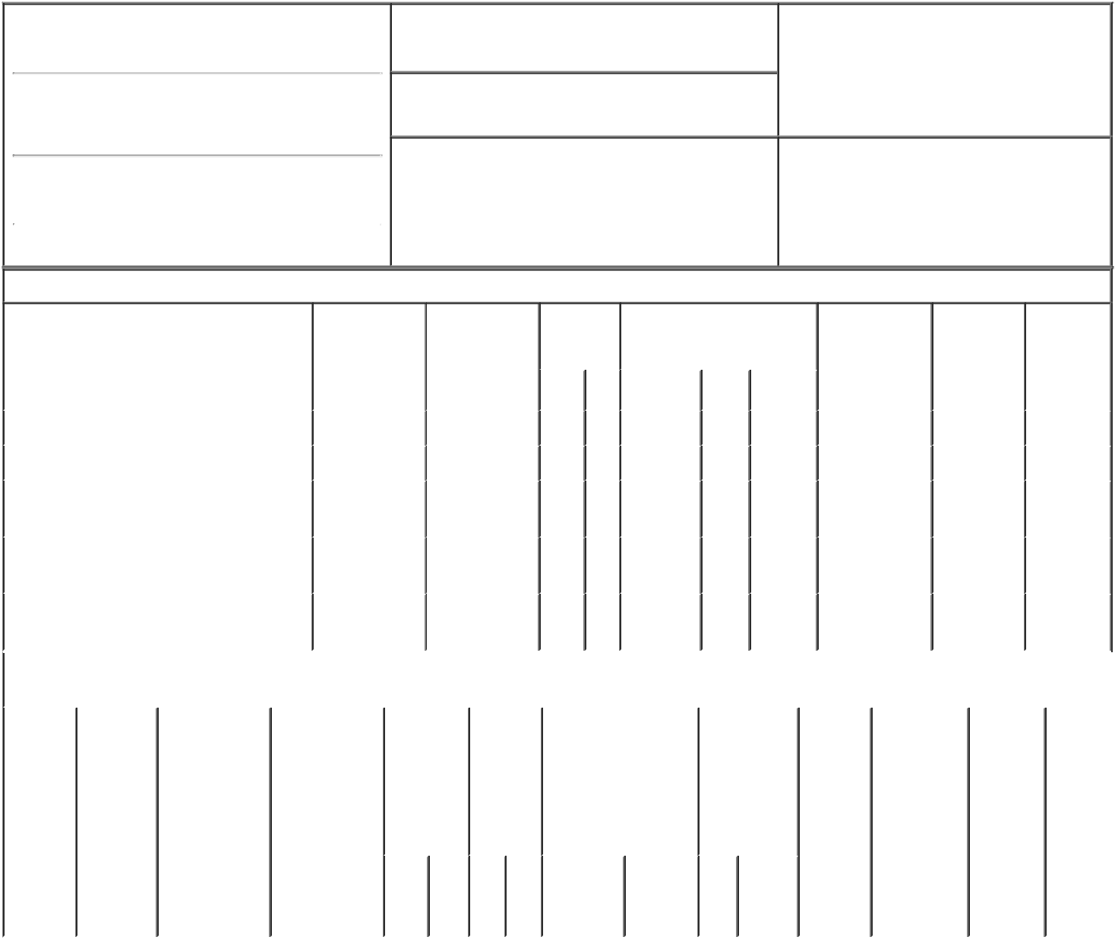

1. Name and Address of Reporting Person*
Manning Paul B

(Last) (First) (Middle)

200 GARRETT STREET, SUITE S

2. Issuer Name and Ticker or Trading Symbol

Verrica Pharmaceuticals Inc. [ VRCA ]

3. Date of Earliest Transaction (Month/Day/Year)

12/02/2021

- Relationship of Reporting Person(s) to Issuer (Check all applicable)
X Director X 10% Owner

Officer (give title Other (specify
below) below)

(Street)
 | CHARLOTTESVILLE VA |  | 22902
 | (City) | (State) | (Zip)

4. If Amendment, Date of Original Filed (Month/Day/Year) 6. Individual or Joint/Group Filing (Check Applicable
Line)
X Form filed by One Reporting Person

Form filed by More than One Reporting
Person

Table I - Non-Derivative Securities Acquired, Disposed of, or Beneficially Owned

 | 1. Title of Security (Instr. 3) |  |  | 2. Transaction |  | 2A. Deemed |  | 3. | 4. Securities Acquired (A) or |  |  |  |  | 5. Amount of |  | 6. Ownership |  | 7. Nature of
 |  |  |  | Date |  | Execution Date, |  | Transaction | Disposed Of (D) (Instr. 3, 4 and |  |  |  |  | Securities |  | Form: Direct |  | Indirect
 |  |  |  | (Month/Day/Year) |  | if any |  | Code (Instr. | 5) |  |  |  |  | Beneficially |  | (D) or Indirect |  | Beneficial
 |  |  |  |  |  | (Month/Day/Year) |  | 8) |  |  |  |  |  | Owned Following |  | (I) (Instr. 4) |  | Ownership
 |  |  |  |  |  |  |  |  |  |  |  |  |  | Reported |  |  |  | (Instr. 4)
 |  |  |  |  |  |  |  | Code V | Amount | (A) or | Price |  |  | Transaction(s)
 |  |  |  |  |  |  |  |  |  | (D) |  |  |  | (Instr. 3 and 4)
 | Common Stock |  |  | 12/02/2021 |  |  |  | P | 30,023 | A | $9.45⁽¹⁾ |  |  | 8,129,417⁽²⁾ |  |  | D
 | Common Stock |  |  | 12/03/2021 |  |  |  | P | 19,977 | A | $9.22⁽³⁾ |  |  | 8,149,394⁽⁴⁾ |  |  | D
 | Common Stock |  |  |  |  |  |  |  |  |  |  |  |  | 739,830 |  |  | I | See
 |  |  |  |  |  |  |  |  |  |  |  |  |  |  |  |  |  | footnote⁽⁵⁾
 | Common Stock |  |  |  |  |  |  |  |  |  |  |  |  | 1,481,719 |  |  | I | See
 |  |  |  |  |  |  |  |  |  |  |  |  |  |  |  |  |  | footnote⁽⁶⁾
 | Common Stock |  |  |  |  |  |  |  |  |  |  |  |  | 256,634 |  |  | I | See
 |  |  |  |  |  |  |  |  |  |  |  |  |  |  |  |  |  | footnote⁽⁷⁾
 |  |  | Table II - Derivative Securities Acquired, Disposed of, or Beneficially Owned
 |  |  |  | (e.g., puts, calls, warrants, options, convertible securities)
 | 1. Title of | 2. | 3. Transaction | 3A. Deemed | 4. |  | 5. Number | 6. Date Exercisable and |  | 7. Title and |  |  | 8. Price of |  | 9. Number of |  | 10. |  | 11. Nature
 | Derivative | Conversion | Date | Execution Date, | Transaction |  | of | Expiration Date |  | Amount of |  |  | Derivative |  | derivative |  | Ownership |  | of Indirect
 | Security | or Exercise | (Month/Day/Year) | if any | Code (Instr. |  | Derivative | (Month/Day/Year) |  | Securities |  |  | Security |  | Securities |  | Form: |  | Beneficial
 | (Instr. 3) | Price of |  | (Month/Day/Year) | 8) |  | Securities |  |  | Underlying |  |  | (Instr. 5) |  | Beneficially |  | Direct (D) |  | Ownership
 |  | Derivative |  |  |  |  | Acquired |  |  | Derivative |  |  |  |  | Owned |  | or Indirect |  | (Instr. 4)
 |  | Security |  |  |  |  | (A) or |  |  | Security (Instr. |  |  |  |  | Following |  | (I) (Instr. 4)
 |  |  |  |  |  |  | Disposed |  |  | 3 and 4) |  |  |  |  | Reported
 |  |  |  |  |  |  | of (D) |  |  |  |  |  |  |  | Transaction(s)
 |  |  |  |  |  |  | (Instr. 3, 4 |  |  |  |  |  |  |  | (Instr. 4)
 |  |  |  |  |  |  | and 5)
 |  |  |  |  |  |  |  |  |  |  | Amount
 |  |  |  |  |  |  |  |  |  |  | or
 |  |  |  |  |  |  |  |  |  |  | Number
 |  |  |  |  |  |  |  | Date | Expiration |  | of
 |  |  |  |  | Code | V | (A) (D) | Exercisable | Date | Title | Shares

Explanation of Responses:

- The price reported in Column 4 is a weighted average price. These shares were purchased in multiple transactions at prices ranging from $9.335 to $9.64 inclusive. The Reporting Person undertakes to provide to the Issuer, any security holder of the Issuer, or the staff of the Securities and Exchange Commission, upon request, full information regarding the number of shares purchased at each separate price within the ranges set forth in footnotes (1) and (3).

- Consists of 7,754,783 shares of common stock held by Mr. Manning and 374,634 shares of common stock held by Mr. Manning jointly with his spouse.

- The price reported in Column 4 is a weighted average price. These shares were purchased in multiple transactions at prices ranging from $9.01 to $9.77 inclusive.

- Consists of 7,754,783 shares of common stock held by Mr. Manning and 394,611 shares of common stock held by Mr. Manning jointly with his spouse.

- The securities are held by The Paul B. Manning Revocable Trust dated May 10, 2000 (the "Trust"). The Reporting Person is the trustee of the Trust and has sole voting and investment power with respect to the shares held by the Trust.

- The shares are held directly by BKB Growth Investments, LLC ("BKB"). The Reporting Person is a co-manager of BKB and has shared voting and investment power with respect to the shares held by BKB.

- The shares are held directly by PBM Capital Investments, LLC ("PBMCI"). The Reporting Person is President and CEO of PBMCI and has sole voting and investment power with respect to the shares held by PBMCI.

Remarks:
/s/ Mark Ballantyne, Attorney- _{12/06/2021}
in-Fact

** Signature of Reporting Person Date

Reminder: Report on a separate line for each class of securities beneficially owned directly or indirectly.

* If the form is filed by more than one reporting person, see Instruction 4 (b)(v).

- Intentional misstatements or omissions of facts constitute Federal Criminal Violations See 18 U.S.C. 1001 and 15 U.S.C. 78ff(a). Note: File three copies of this Form, one of which must be manually signed. If space is insufficient, see Instruction 6 for procedure.
Persons who respond to the collection of information contained in this form are not required to respond unless the form displays a currently valid OMB Number.

